**MANUAL TESTING**

What is meant by Testing

< Testing is to prove that the build/software is working fine as per the client

Requirements

---------------------------------------------------------------------------------------------------------------------

1. Topics Covered in Manual Testing.
2. Smoke Testing.
3. Sanity Testing.
4. Progression Testing
5. Regression Testing
6. Performance Testing
7. Load Testing
8. Stress Testing
9. Security Testing.
10. Defect Parameter
11. Format of Defect Parameter
12. Test Cases Format.
13. Defect Life Cycle
14. Test Cases Status.

---------------------------------------------------------------------------------------------------------------------

1. What is meant by Smoke Testing

< Smoke testing means we will go ahead and check all the high level Spot checks.

< We will not having any planed test cases in Smoke testing

< We will not go in depth of any application or module in smoke Testing.

< Smoke testing is the first thing we will doing once the build is released from the Development team

---------------------------------------------------------------------------------------------------------------------

1. What is meant by Sanity Testing

< We will do sanity testing when the build is stable.

< When it is not stable we will go ahead and tell the development that build is not stable and can you please check from your end.

<one the build is stable we will doing Sanity testing

< In Sanity testing each and every single module we will plan one or two test cases

< We will go in deep and we need to check one or two test cases in each and every single module whether they are working fine as per the client requirement or not.

---------------------------------------------------------------------------------------------------------------------

1. What is meant by Progression Testing

< Checking the new functionality that is been added weather it is working fine as per client requirement or not is known as Progression Testing.

---------------------------------------------------------------------------------------------------------------------

1. What is meant by Regression Testing

< Checking the old functionality weather it is working fine as per the client requirement or not is known as Regression Testing.

(Or)

< Re-executing of all existing test cases is known as Regression Testing.

---------------------------------------------------------------------------------------------------------------------

Why we will do regression testing?

< In order to check because of the new functionalities that are been added we should be making sure that the old functionality is not getting effected.

---------------------------------------------------------------------------------------------------------------------

1. What is meant by Performance Testing?

<Performance testing is a software testing process used for testing the

1. Speed

<The speed at which the application is responding.

1. Response Time
2. Stability

<Determines maximum user load the software application can handle.

1. Scalability

<Determines if the Application is stable under various loads.

1. Reliability and resource usage of software under particular workload.

---------------------------------------------------------------------------------------------------------------------

1. What is meant by Load Testing?

<Verifying the application access, connectivity, Transactional/Operational activities are perfectly working or not.

<When concurrent users accessing the application at the same time

< And measuring the performance under client expected load is meeting or not.

---------------------------------------------------------------------------------------------------------------------

1. What is meant by Stress Testing?

<Increasing the maximum load of users and verifying the maximum peak limit or break point of the system access and measuring the system performance.

<in other words Stress tests help you to determine how a system would behave under an extreme load such as DDoS, Slashdot effect, or other Scenarios.

---------------------------------------------------------------------------------------------------------------------

What are differences between Load Test & Stress Test?

<The Key difference is.

<Load test helps you to understand how a system behaves under expected load.

<Stress test helps you understand the upper limit of a system’s capacity using a load beyond the expected maximum.

---------------------------------------------------------------------------------------------------------------------

1. What is meant by Security testing?

<Verifying the system access and protection from unauthorized users,

<System should maintain encryption and decryption techniques during

<message/mail transfers

<maintaining security for Debit/Card or bank Transactions

<Password protection, implementing OTP checks

<All this comes under security testing.

---------------------------------------------------------------------------------------------------------------------

1. What is Defect Parameter

< Whenever we will get an error while testing particular case we will be writing it in the format of Defect Parameter.

<In Defect Parameter you will tell the defect you received & in which step you received the error.

---------------------------------------------------------------------------------------------------------------------

1. What is the format of Defect Parameter?
2. Issue Description: what is the issue of that particular step.
3. Step to reproduce: at which step you received defect.
4. Actual Result:

<What is the result that we have revised while executing that particular test case

1. Expected Results:

<What is the result that we were expecting out of that particular step.

1. Test Environment:

<What is the URL you working on and username, password.

1. Test Data:

< if you have any client information in such particular you want to mention in consumer no

1. Priority :( p1, p2, p3, p4).

<P1= Critical –While Entering URL.

<P2= High-While login to that particular website .

1. Severirty: :( S1, S2, S3, S4).

<S1= Critical –Immediately the error should be fixed.

<S2= High-

1. Assigned:

< Development team person whom the defect is been assigned.

1. Status:

<The status of that particular defect should be always New.

1. Test Phase:
2. SIT: System Integrating Testing.
3. FAT: Functional Acceptance Testing.
4. UAT: User Acceptance Testing

---------------------------------------------------------------------------------------------------------------------

1. What is the format of test case
2. Test case Id
3. Objective of that Test Case
4. Steps: in order to achieve that test case.
5. Description for each step.
6. Expected Result of particular step.
7. Type
8. Designer
9. Subject-
10. Actual Result
11. **What is Defect Life Cycle.**

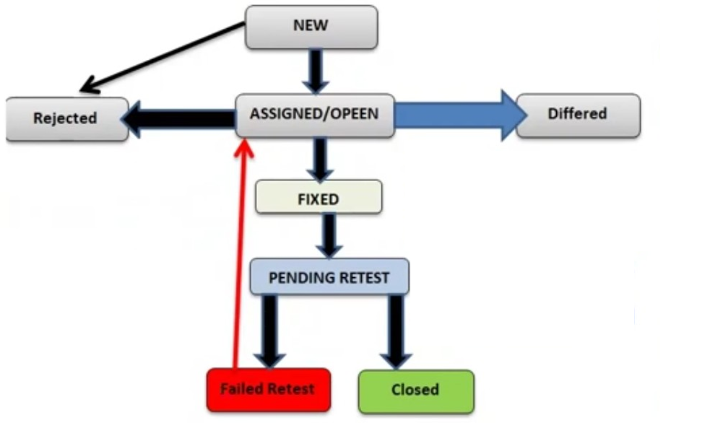

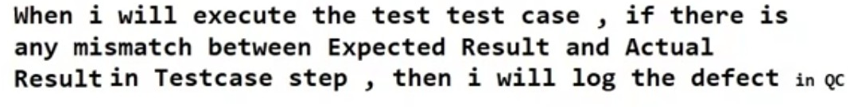





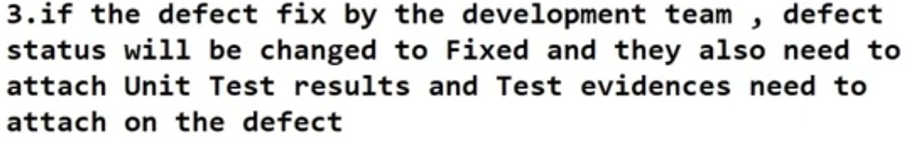

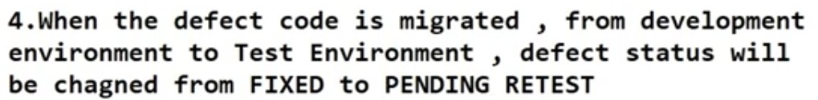

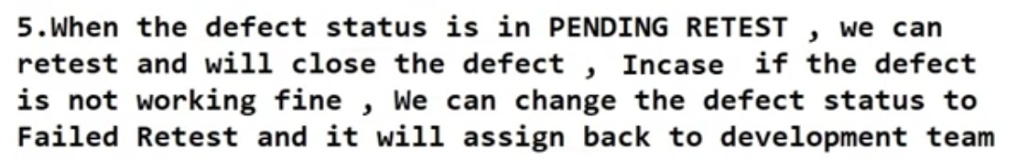

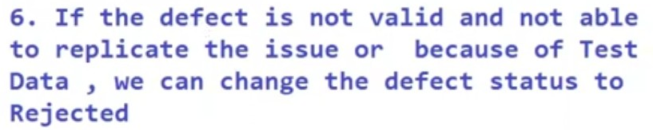

1. If the defect is valid and not fixing in current release, target for future release the defect status will be changed to differed.

---------------------------------------------------------------------------------------------------------------------

1. In how many ways we will provide the status in Test Cases?
2. Passed.
3. Failed.
4. No Run:

< We haven’t written or tested anything on that particular test case.

1. Blocked:

< While we are writing test case. if I get some error at some particular step.

<for that particular step I am telling the development team that at this particular step we are getting an error please solve from your end.

<The same error I am getting in next step also then we will keep it in Blocked

<Because at the previous step I already informed to development team and they are fixing that issue,

<and I need not lock this particular defect once again in defect parameter

<instead of that I can say the status of particular step as Blocked.

1. Not Completed:

< Executed some Steps in test cases.

---------------------------------------------------------------------------------------------------------------------